**REST Hands-on 1: "Hello World" RESTful Web Service**

**Goal:**

Create a simple **REST API using Spring Boot** that returns "Hello World!!" on a GET request to /hello.

**Create Controller Class**

In existing project (spring-learn), go to:

* src/main/java/com/cognizant/spring_learn/

Create a new package:

**com.cognizant.spring_learn.controller**

Inside it, create a new class:

**HelloController.java**

package com.cognizant.springlearn.controller;

import org.slf4j.Logger;

import org.slf4j.LoggerFactory;

import org.springframework.web.bind.annotation.GetMapping;

import org.springframework.web.bind.annotation.RestController;

@RestController

public class HelloController {

private static final Logger LOGGER = LoggerFactory.getLogger(HelloController.class);

@GetMapping("/hello")

public String sayHello() {

LOGGER.info("START");

String message = "Hello World!!";

LOGGER.info("END");

return message;

}

}

3. **Update application.properties**

server.port=8083

logging.level.org.springframework=info

logging.level.com.cognizant.springlearn=debug

logging.pattern.console=%d{yyMMdd}|%d{HH:mm:ss.SSS}|%-20.20thread|%5p|%-25.25logger{25}|%25M|%m%n

**4. Run the Application**

Right-click on SpringLearnApplication.java → **Run As > Java Application**

**Output:**

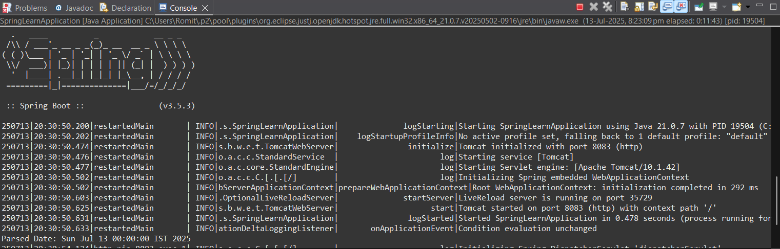

**5. Test the Endpoint**

**Using Browser:**

* Open: <http://localhost:8083/hello>

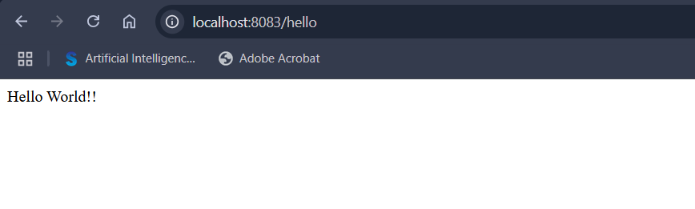

**REST Hands-on 2: /country – Return India Country Details**

**Goal:**

Create a REST endpoint that returns **India’s country details** (code + name) by loading it from the Spring XML config file (country.xml).

**1.**create **Country.xml** in **src/main/resources**

<?xml version="1.0" encoding="UTF-8"?>

<beans xmlns="http://www.springframework.org/schema/beans"

xmlns:xsi="http://www.w3.org/2001/XMLSchema-instance"

xsi:schemaLocation="

http://www.springframework.org/schema/beans

https://www.springframework.org/schema/beans/spring-beans.xsd">

<bean id="country" class="com.cognizant.springlearn.Country">

<property name="code" value="IN" />

<property name="name" value="India" />

</bean>

</beans>

**2.** create **country.java** in **com.cognizant.spring_learn**

package com.cognizant.spring_learn;

public class country {

private String code;

private String name;

public country() {

System.out.println("Inside Country Constructor.");

}

public String getCode() {

System.out.println("Getting code");

return code;

}

public void setCode(String code) {

System.out.println("Setting code");

this.code = code;

}

public String getName() {

System.out.println("Getting name");

return name;

}

public void setName(String name) {

System.out.println("Setting name");

this.name = name;

}

@Override

public String toString() {

return "Country [code=" + code + ", name=" + name + "]";

}

}

**3.**create **CountryController.java** in **com.cognizant.spring_learn.controller**

package com.cognizant.springlearn.controller;

import com.cognizant.springlearn.Country;

import org.slf4j.Logger;

import org.slf4j.LoggerFactory;

import org.springframework.context.ApplicationContext;

import org.springframework.context.support.ClassPathXmlApplicationContext;

import org.springframework.web.bind.annotation.RequestMapping;

import org.springframework.web.bind.annotation.RestController;

@RestController

public class CountryController {

private static final Logger LOGGER = LoggerFactory.getLogger(CountryController.class);

@RequestMapping("/country")

public Country getCountryIndia() {

LOGGER.info("START");

ApplicationContext context = new ClassPathXmlApplicationContext("country.xml");

Country country = context.getBean("country", Country.class);

LOGGER.debug("Country : {}", country.toString());

LOGGER.info("END");

return country;

}

}

**4. Run the Application**

* Make sure SpringLearnApplication.java is still the main class.
* Run it again using **Run As > Java Application**.

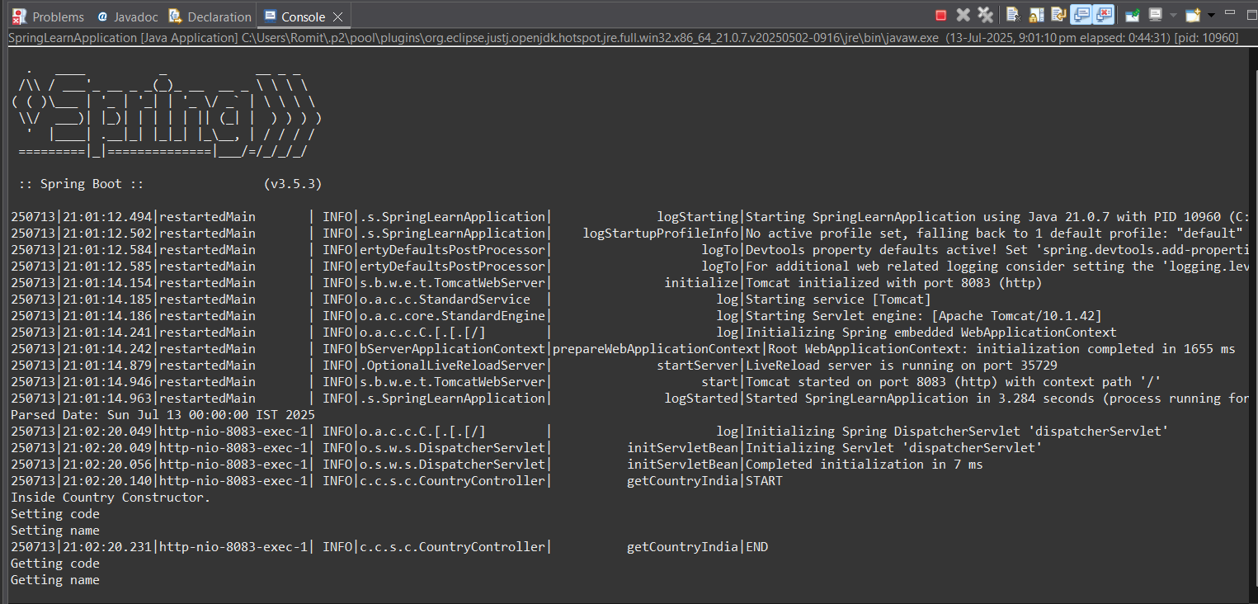

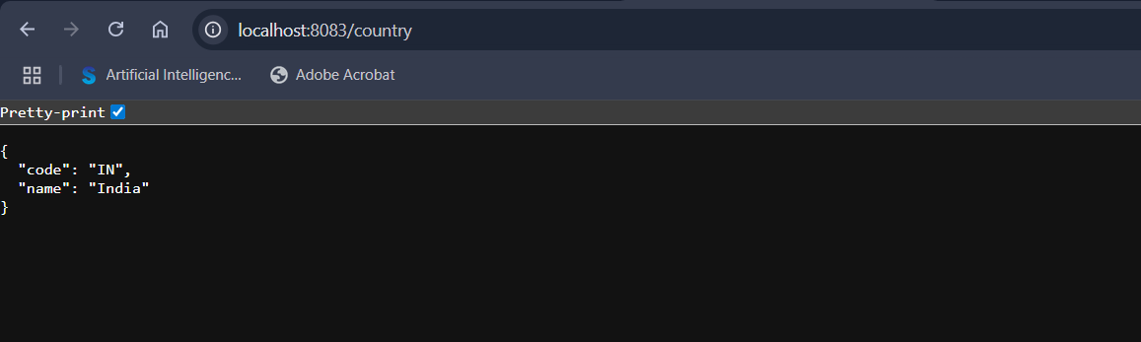

**REST Hands-on 3: /countries – Return All Countries**

**Goal:**

Create a REST endpoint that returns **all countries** from the Spring XML config (country.xml) as a list of JSON objects.

**1.Update country.xml with All Countries**

<?xml version="1.0" encoding="UTF-8"?>

<beans xmlns="http://www.springframework.org/schema/beans"

xmlns:xsi="http://www.w3.org/2001/XMLSchema-instance"

xsi:schemaLocation="

http://www.springframework.org/schema/beans

https://www.springframework.org/schema/beans/spring-beans.xsd">

<bean id="in" class="com.cognizant.spring_learn.country">

<property name="code" value="IN" />

<property name="name" value="India" />

</bean>

<bean id="us" class="com.cognizant.spring_learn.country">

<property name="code" value="US" />

<property name="name" value="United States" />

</bean>

<bean id="jp" class="com.cognizant.spring_learn.country">

<property name="code" value="JP" />

<property name="name" value="Japan" />

</bean>

<bean id="de" class="com.cognizant.spring_learn.country">

<property name="code" value="DE" />

<property name="name" value="Germany" />

</bean>

<bean id="countryList" class="java.util.ArrayList">

<constructor-arg>

<list>

<ref bean="in"/>

<ref bean="us"/>

<ref bean="jp"/>

<ref bean="de"/>

</list>

</constructor-arg>

</bean>

</beans>

**2. Add Method in CountryController.java**

import java.util.List;

@RequestMapping("/countries")

public List<Country> getAllCountries() {

LOGGER.info("START");

ApplicationContext context = new ClassPathXmlApplicationContext("country.xml");

List<Country> countries = (List<Country>) context.getBean("countryList");

LOGGER.debug("Countries : {}", countries.toString());

LOGGER.info("END");

return countries;

}

**3. ✅ Run the Application**

* Save all changes.
* Run SpringLearnApplication.java

**Output:**

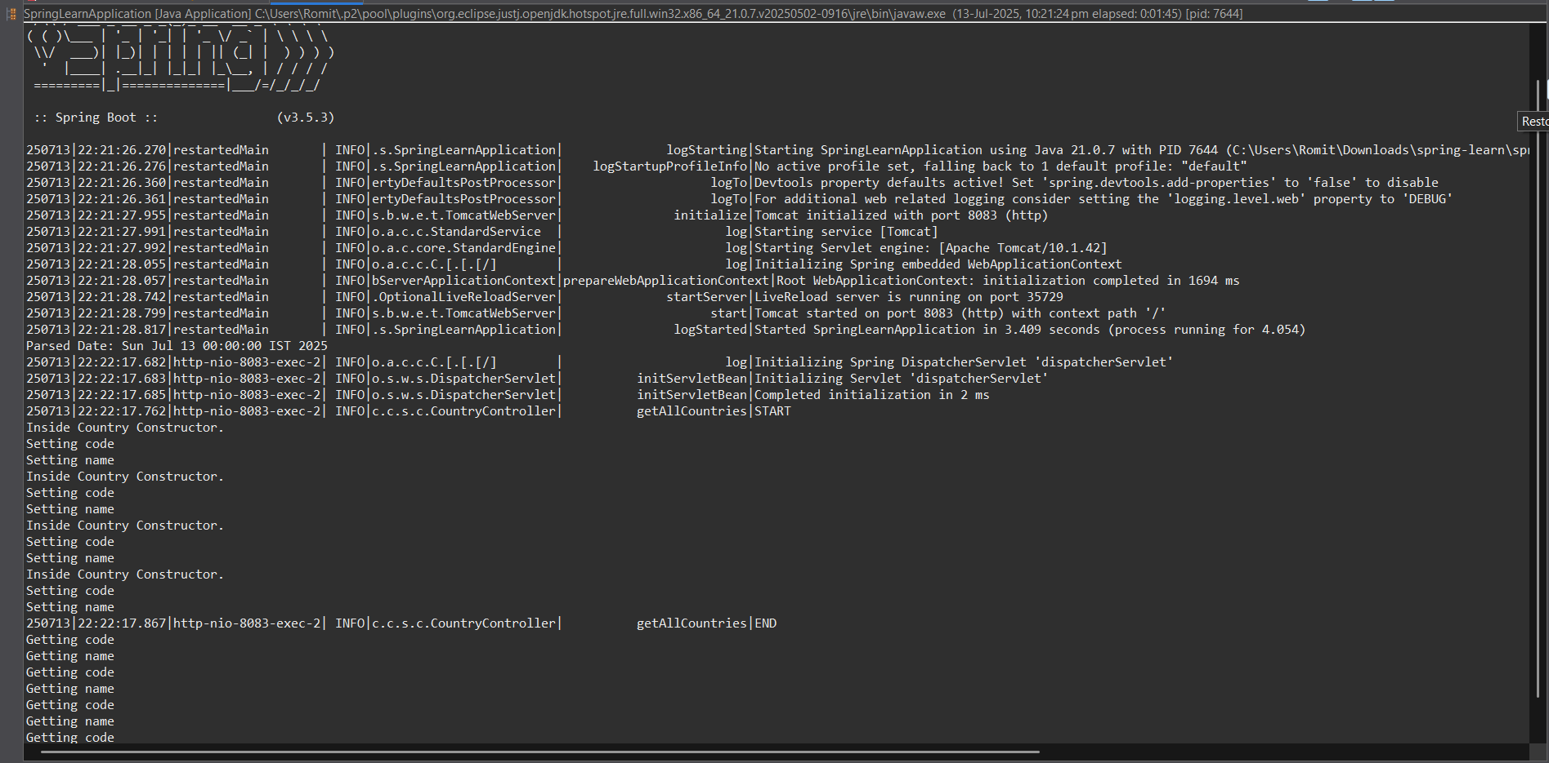

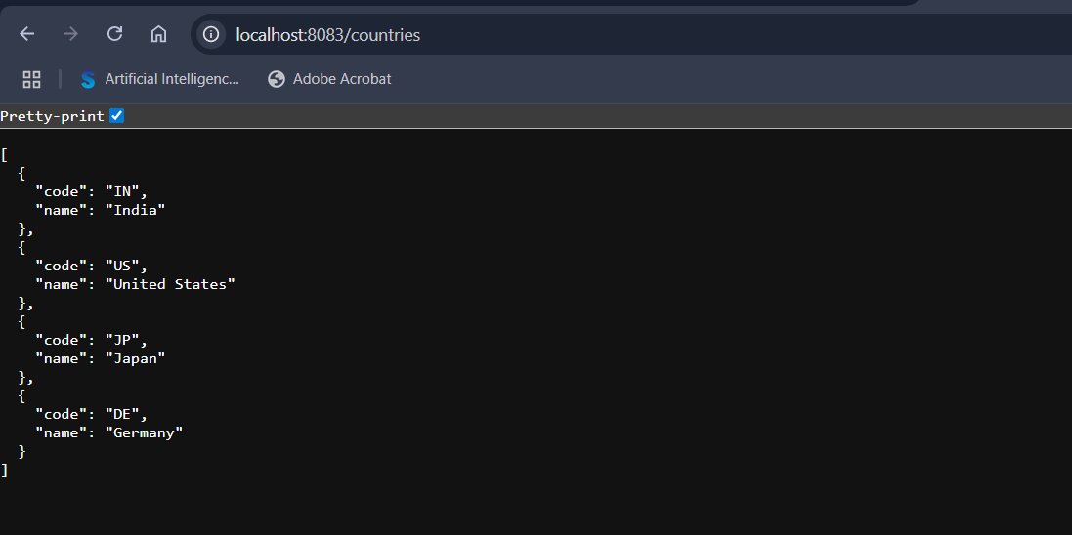

**Hands-on 5: REST – Get Country by Country Code (/countries/{code})**

**Goal:**

Build a REST endpoint that accepts a **country code as a path variable** (case-insensitive) and returns the matching country from XML.

**1. Update or Create CountryService.java**

In **com.cognizant.springlearn.service,** create a class:

package com.cognizant.spring_learn.service;

import com.cognizant.springlearn.country;

import org.springframework.context.ApplicationContext;

import org.springframework.context.support.ClassPathXmlApplicationContext;

import org.springframework.stereotype.Service;

import java.util.List;

@Service

public class CountryService {

public Country getCountry(String code) {

ApplicationContext context = new ClassPathXmlApplicationContext("country.xml");

List<country> countries = (List<Country>) context.getBean("countryList");

for (country c : countries) {

if (c.getCode().equalsIgnoreCase(code)) {

return c;

}

}

return null;

}

}

2. **Update CountryController.java**

import com.cognizant.spring_learn.service.CountryService;

import org.springframework.beans.factory.annotation.Autowired;

import org.springframework.web.bind.annotation.GetMapping;

import org.springframework.web.bind.annotation.PathVariable;

@RestController

public class CountryController {

@Autowired

private CountryService countryService;

@GetMapping("/countries/{code}")

public Country getCountry(@PathVariable String code) {

LOGGER.info("START");

country country = countryService.getCountry(code);

LOGGER.debug("Country : {}", country.toString());

LOGGER.info("END");

return country;

}

}

**4. Run the App**

* Restart application (SpringLearnApplication.java)

**Output:**



